Name: Janet Adetoun Adewusi
Course: COMP122
Date: 2026-02-20

Questions [10 marks]

Create 3 tables based on the ER diagram shown below. Include necessary constraints in the CREATE TABLE statements. Name all constraints except NOT NULL properly

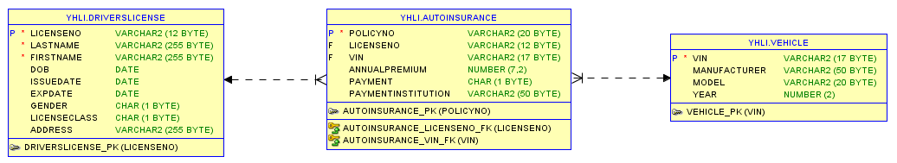
DRIVERSLICENSE TABLE
CREATE TABLE YHLDRIVERSLICENSE (
LICENSENO VARCHAR2(12) NOT NULL,
LASTNAME VARCHAR2(255) NOT NULL,
FIRSTNAME VARCHAR2(255) NOT NULL,
DOB DATE NOT NULL,
ISSUEDATE DATE NOT NULL,
EXPDATE DATE NOT NULL,
GENDER CHAR(1) NOT NULL,
LICENSECLASS VARCHAR2(2) NOT NULL,
ADDRESS VARCHAR2(255) NOT NULL,
CONSTRAINT DRIVERSLICENSE_PK PRIMARY KEY (LICENSENO)
);
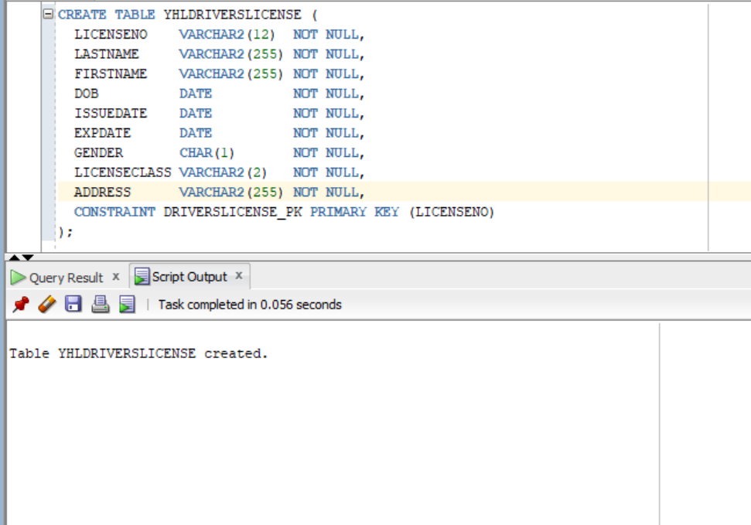
AUTOINSURANCE TABLE
CREATE TABLE YHLAUTOINSURANCE (
POLICYNO VARCHAR2(20),
LICENSENO VARCHAR2(12),
VIN VARCHAR2(17),
ANNUALPREMIUM NUMBER(7,2),
PAYMENT CHAR(10),
PAYMENTINSTITUTION VARCHAR2(50),

CONSTRAINT AUTOINSURANCE_PK
PRIMARY KEY (POLICYNO),

CONSTRAINT AUTOINSURANCE_LICENSE_FK
FOREIGN KEY (LICENSENO)
REFERENCES YHLDRIVERSLICENSE (LICENSENO),

CONSTRAINT AUTOINSURANCE_VIN_FK
FOREIGN KEY (VIN)
REFERENCES YHLVEHICLE (VIN)
);

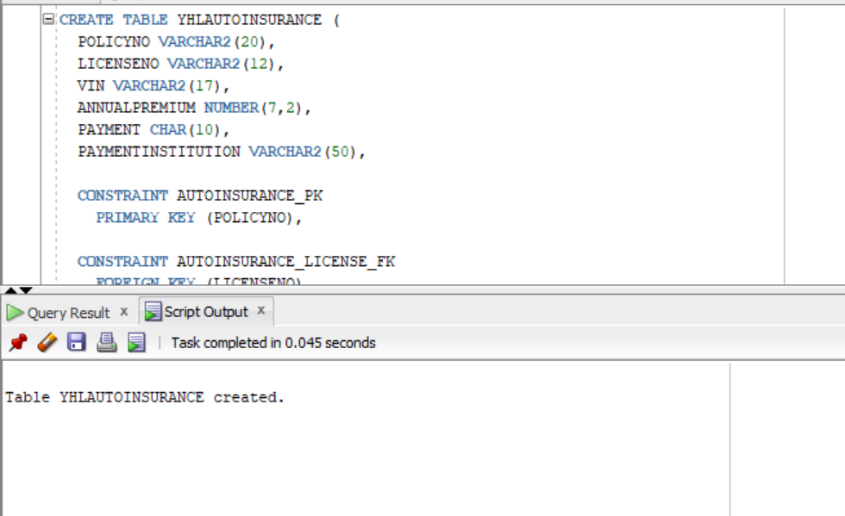
VEHICLE TABLE
CREATE TABLE YHLVEHICLE (
VIN VARCHAR2(17),
MANUFACTURER VARCHAR2(50),
MODEL VARCHAR2(20),
YEAR NUMBER(4),

CONSTRAINT VEHICLE_PK
PRIMARY KEY (VIN)
);
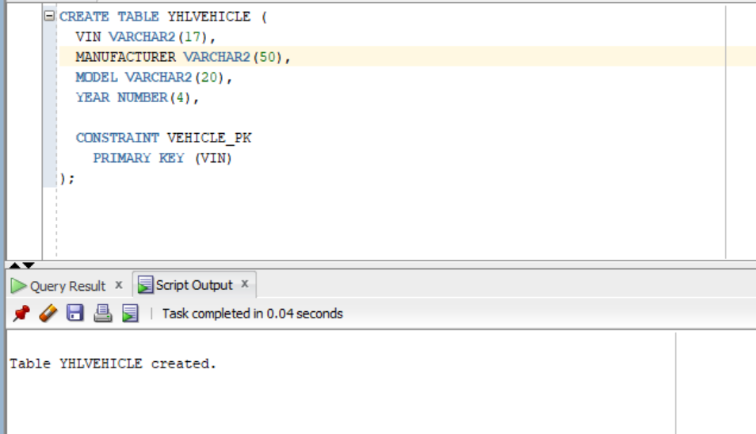

- [2 marks] For table DriversLicense, in addition to primary key, you should add more constraints in this table
  - Add check constraint for Gender column, for simplicity’s sake, the value can only be ‘F’ or ‘M’
ALTER TABLE YHLDRIVERSLICENSE
ADD CONSTRAINT DRIVERSLICENSE_GENDER_CK
CHECK (GENDER IN ('F','M'));

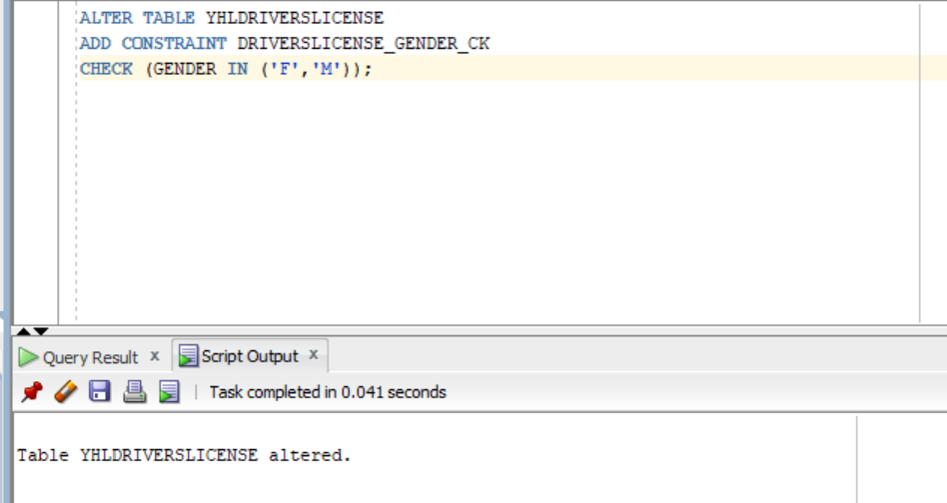
  - Add check constraint for LicenseClass column, there are 12 types of Driver’s Licenses in Ontario, G, G1, G2, M, M1, M2, A, B, C, D, E, F (https://www.hubinsurancehunter.ca/blog/12-types-drivers-licences-ontario/)
Part 1—Change column size
ALTER TABLE YHLDRIVERSLICENSE
MODIFY (LICENSECLASS VARCHAR2(2));
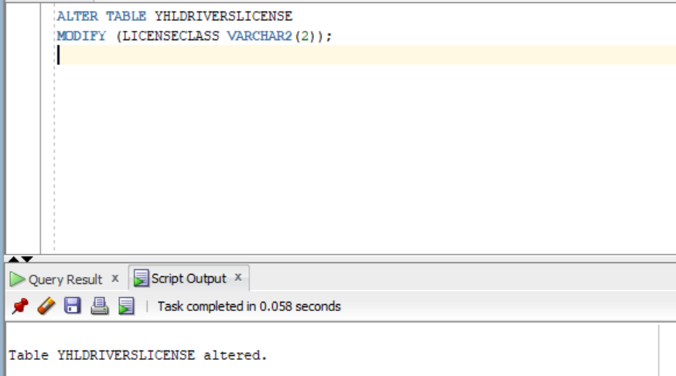
Part 2—Add CHECK Constraint
ALTER TABLE YHLDRIVERSLICENSE
ADD CONSTRAINT DRIVERSLICENSE_CLASS_CK
CHECK (LICENSECLASS IN ('G','G1','G2','M','M1','M2','A','B','C','D','E','F'));
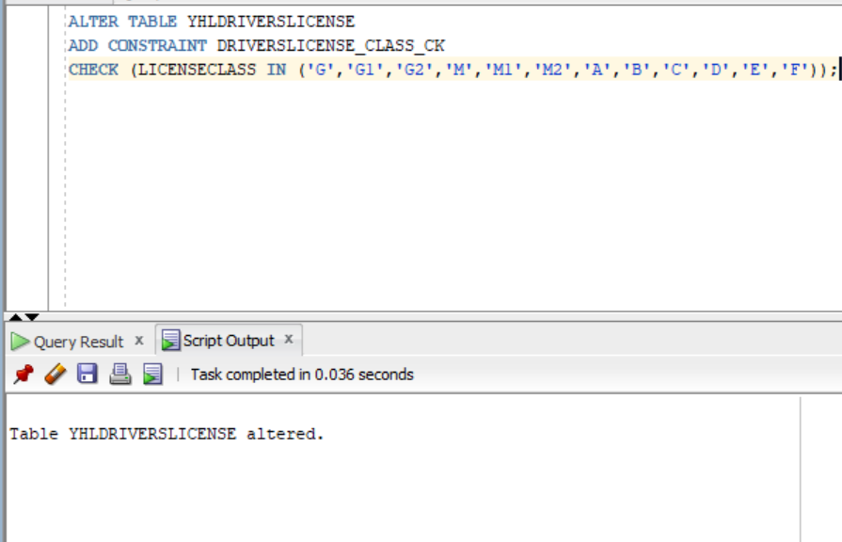
  - IssueDate should be earlier than ExpDate
ALTER TABLE YHLDRIVERSLICENSE
ADD CONSTRAINT DRIVERSLICENSE_DATE_CK
CHECK (ISSUEDATE < EXPDATE);
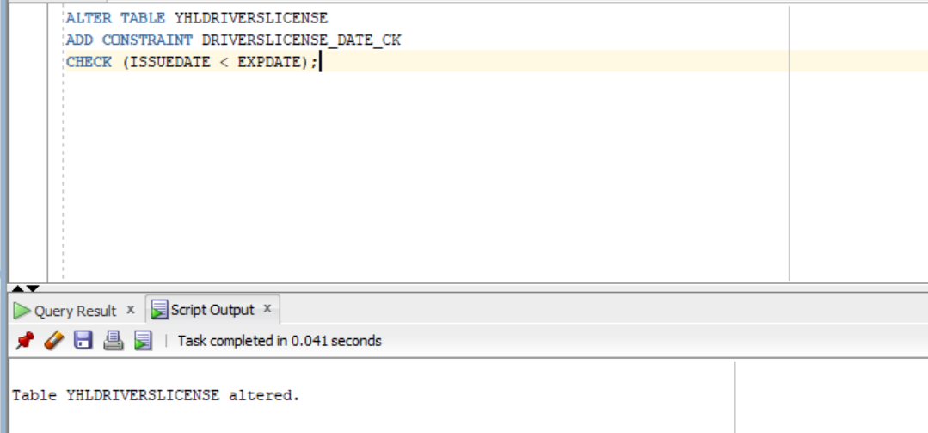

- [2 marks] For table AutoInsurance, in addition to primary key and foreign keys, more constraints should be added
  - For Payment column, make sure that only accept two values, Monthly or Annually
ALTER TABLE YHLAUTOINSURANCE
ADD CONSTRAINT AUTOINSURANCE_PAYMENT_CK
CHECK (PAYMENT IN ('Monthly','Annually'));
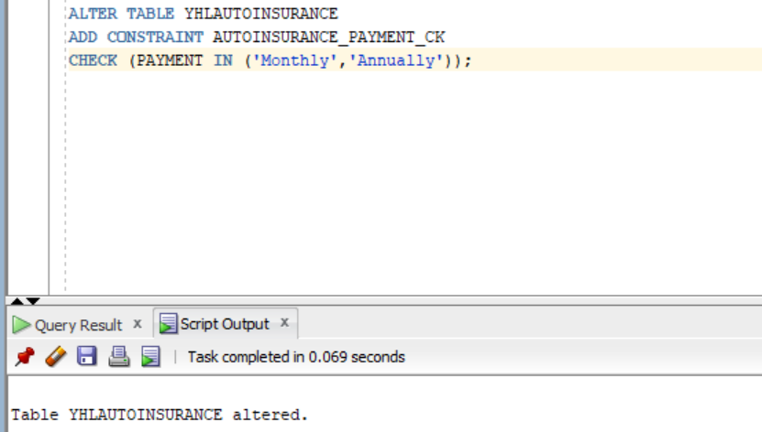
  - Add more columns, policy start date and policy end date, policy owner’s name
ALTER TABLE YHLAUTOINSURANCE
ADD (
POLICY_START_DATE DATE,
POLICY_END_DATE DATE,
POLICY_OWNER_NAME VARCHAR2(255)
);
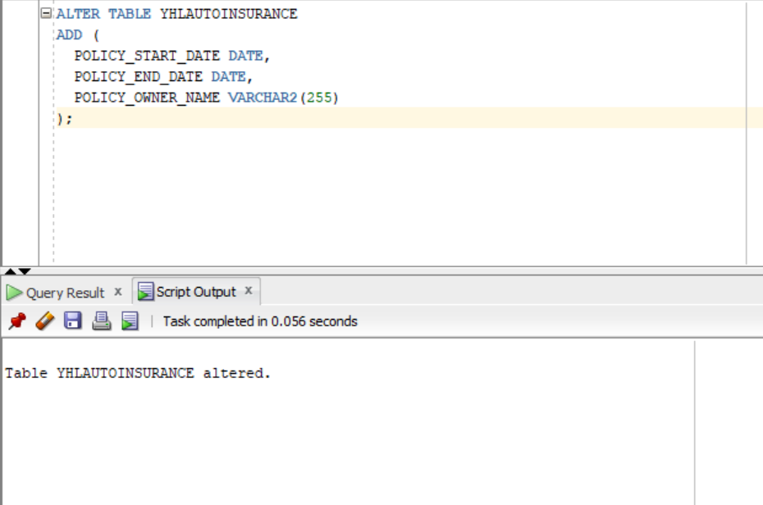

- [2 marks] For table Vehicle, do some research, and add more columns with appropriate constraint(s)
Step 1—ADD COLUMNS
ALTER TABLE YHLVEHICLE
ADD (
PLATE_NO VARCHAR2(10),
COLOR VARCHAR2(20),
FUEL_TYPE VARCHAR2(10),
DOORS NUMBER(1)
);
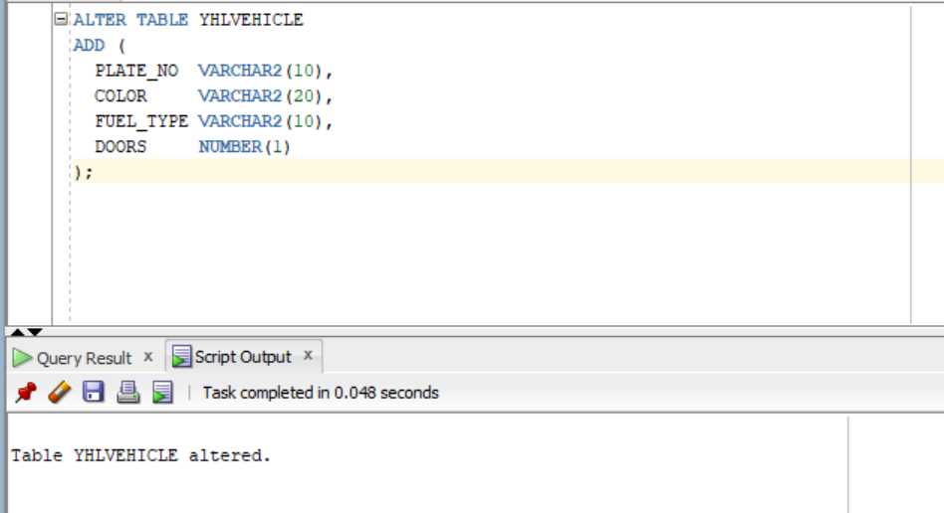
Step 2—ADD CONSTRAINTS
- Plate number unique
ALTER TABLE YHLVEHICLE
ADD CONSTRAINT VEHICLE_PLATE_UQ
UNIQUE (PLATE_NO);
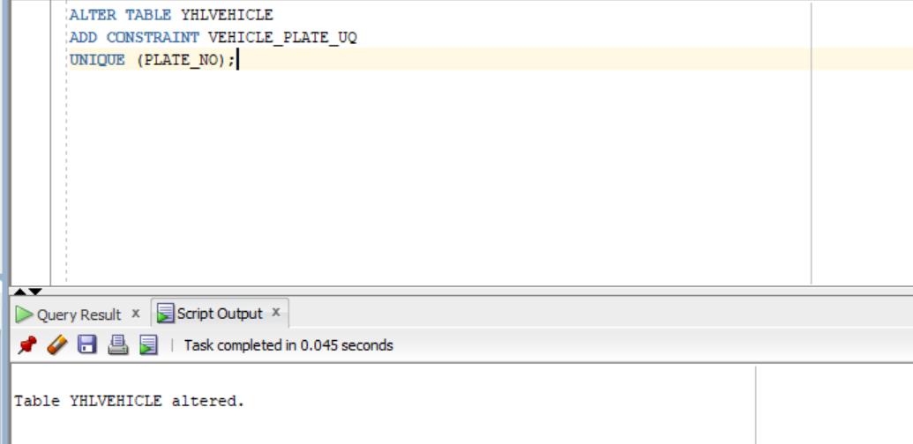
- Fuel type Limited
ALTER TABLE YHLVEHICLE
ADD CONSTRAINT VEHICLE_FUEL_CK
CHECK (FUEL_TYPE IN ('Gas','Diesel','Hybrid','Electric'));
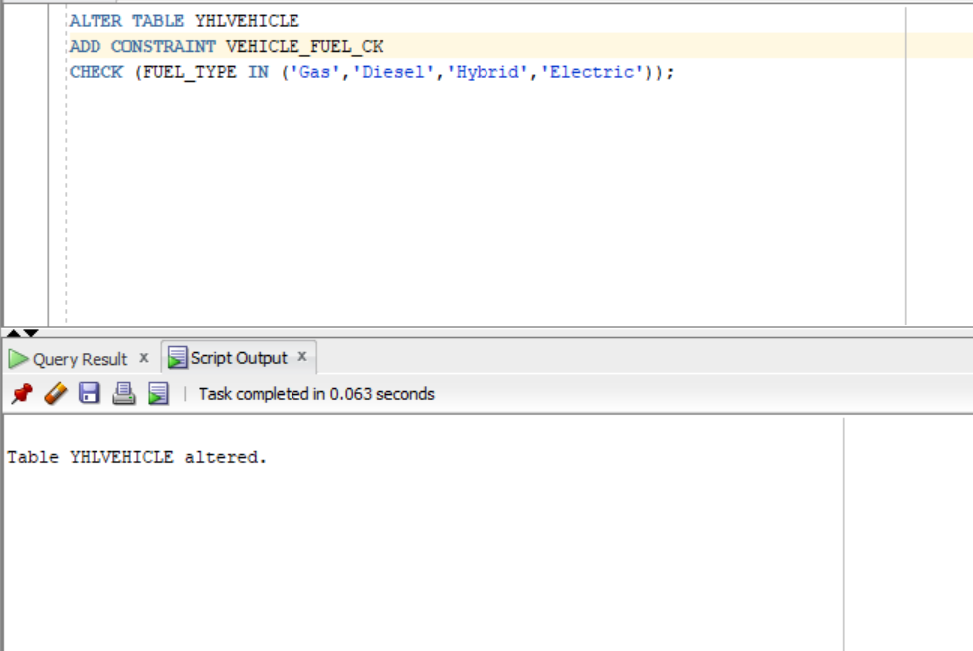
- Door realistic
ALTER TABLE YHLVEHICLE
ADD CONSTRAINT VEHICLE_DOORS_CK
CHECK (DOORS BETWEEN 2 AND 5);
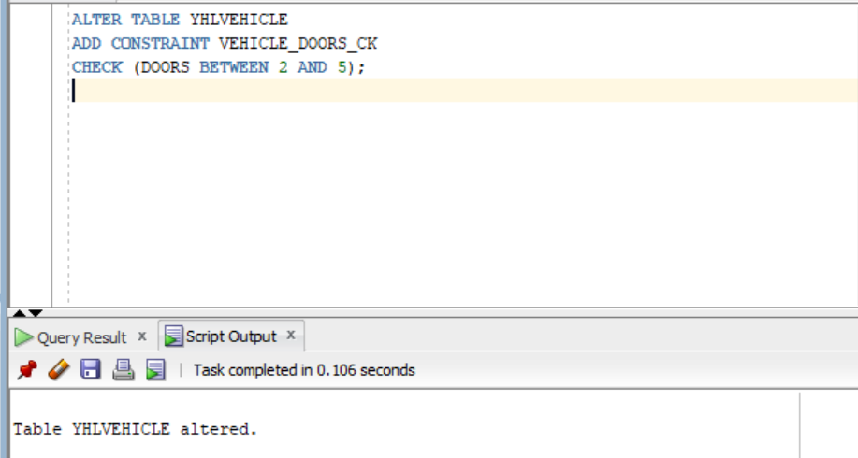
- Color limited
ALTER TABLE YHLVEHICLE
ADD CONSTRAINT VEHICLE_COLOR_CK
CHECK (COLOR IN ('Black','White','Red','Blue','Silver','Gray'));
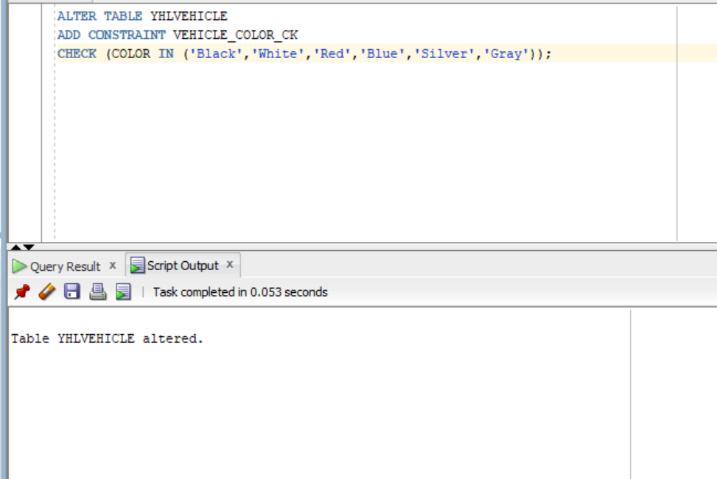
STEP 3—Show table adjustments
DESC YHLVEHICLE;
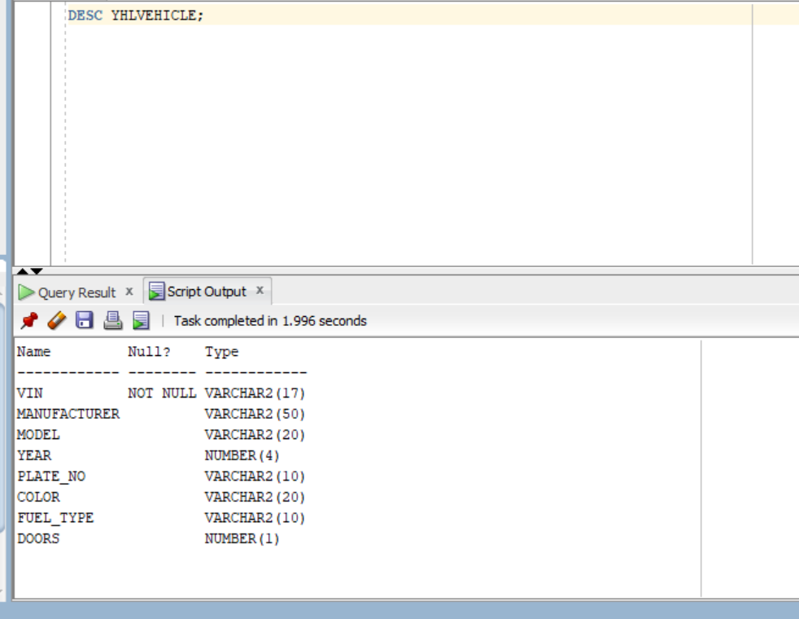
- [4 marks] For each table, insert at least 4 rows
- Insert 4 rows into YHLVEHICLE
INSERT ALL
INTO YHLVEHICLE (VIN, MANUFACTURER, MODEL, YEAR, PLATE_NO, COLOR, FUEL_TYPE, DOORS)
VALUES ('1HGCM82633A004352', 'Honda', 'Accord', 2018, 'ON12345', 'Black', 'Gas', 4)
INTO YHLVEHICLE (VIN, MANUFACTURER, MODEL, YEAR, PLATE_NO, COLOR, FUEL_TYPE, DOORS)
VALUES ('2T1BURHE6JC073421', 'Toyota', 'Corolla', 2020, 'ON67890', 'White', 'Gas', 4)
INTO YHLVEHICLE (VIN, MANUFACTURER, MODEL, YEAR, PLATE_NO, COLOR, FUEL_TYPE, DOORS)
VALUES ('5YJ3E1EA7KF317654', 'Tesla', 'Model3', 2022, 'ON24680', 'Blue', 'Electric', 4)
INTO YHLVEHICLE (VIN, MANUFACTURER, MODEL, YEAR, PLATE_NO, COLOR, FUEL_TYPE, DOORS)
VALUES ('1FTFW1E50JFB91234', 'Ford', 'F150', 2019, 'ON13579', 'Gray', 'Hybrid', 4)
SELECT 1 FROM DUAL;
SELECT * FROM YHLVEHICLE;
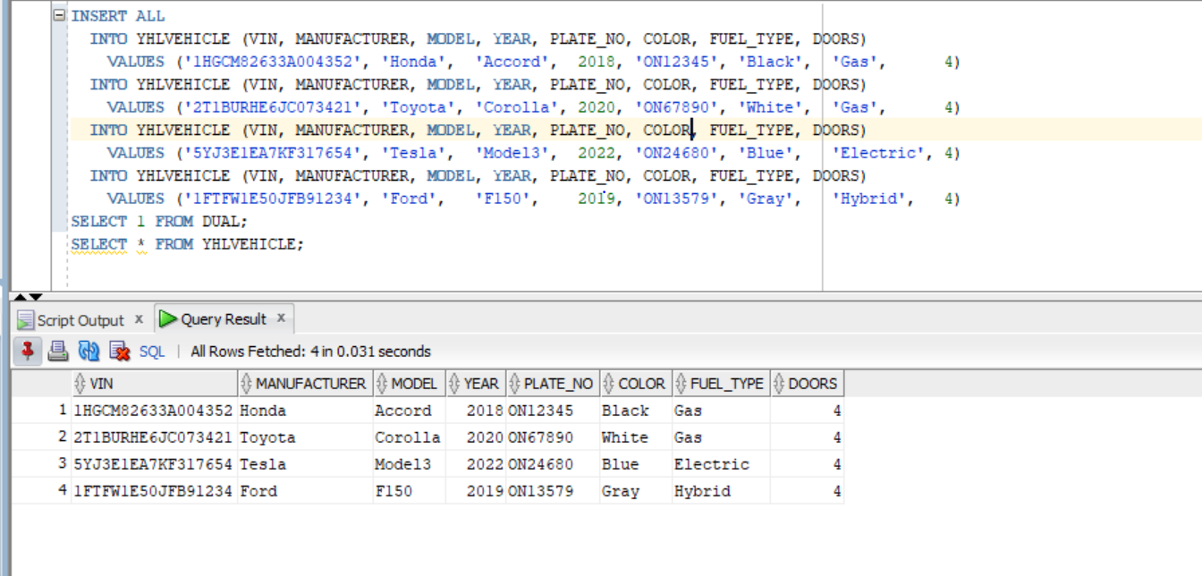

- Insert 4 rows into YHLDRIVERSLICENSE
INSERT ALL
INTO YHLDRIVERSLICENSE (LICENSENO, LASTNAME, FIRSTNAME, DOB, ISSUEDATE, EXPDATE, GENDER, LICENSECLASS, ADDRESS)
VALUES ('DL100000001', 'Smith', 'John', DATE '2002-05-12', DATE '2022-06-01', DATE '2027-06-01', 'M', 'G', '12 King St, Toronto')
INTO YHLDRIVERSLICENSE (LICENSENO, LASTNAME, FIRSTNAME, DOB, ISSUEDATE, EXPDATE, GENDER, LICENSECLASS, ADDRESS)
VALUES ('DL100000002', 'Brown', 'Aisha', DATE '2003-11-20', DATE '2023-01-10', DATE '2028-01-10', 'F', 'G2', '55 Queen St, Ottawa')
INTO YHLDRIVERSLICENSE (LICENSENO, LASTNAME, FIRSTNAME, DOB, ISSUEDATE, EXPDATE, GENDER, LICENSECLASS, ADDRESS)
VALUES ('DL100000003', 'Chen', 'Wei', DATE '2001-03-02', DATE '2021-09-15', DATE '2026-09-15', 'M', 'G1', '9 Main St, London')
INTO YHLDRIVERSLICENSE (LICENSENO, LASTNAME, FIRSTNAME, DOB, ISSUEDATE, EXPDATE, GENDER, LICENSECLASS, ADDRESS)
VALUES ('DL100000004', 'Jones', 'Mary', DATE '1999-07-08', DATE '2020-08-01', DATE '2025-08-01', 'F', 'M', '77 Lake Rd, Hamilton')
SELECT 1 FROM DUAL;
SELECT * FROM YHLDRIVERSLICENSE;
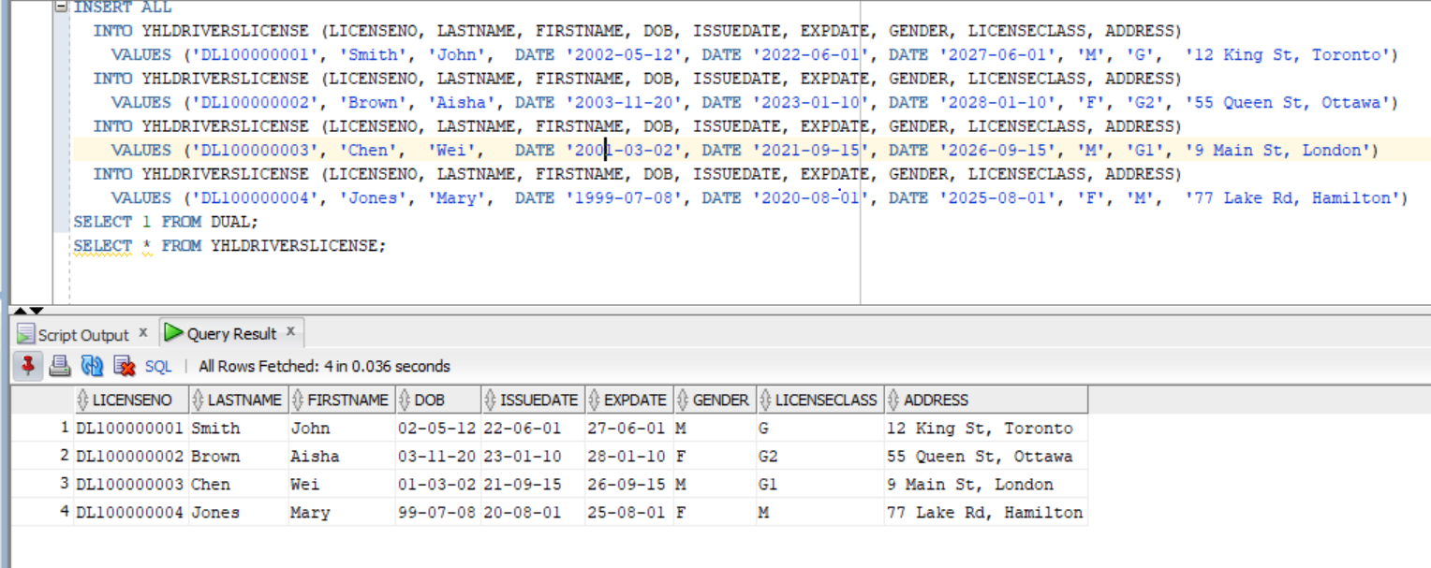
- Insert 4 rows into YHLAUTOINSURANCE
INSERT ALL
INTO YHLAUTOINSURANCE (POLICYNO, LICENSENO, VIN, ANNUALPREMIUM, PAYMENT, PAYMENTINSTITUTION, POLICY_START_DATE, POLICY_END_DATE, POLICY_OWNER_NAME)
VALUES ('P1001', 'DL100000001', '1HGCM82633A004352', 1800.50, 'Monthly', 'TD', DATE '2025-01-01', DATE '2025-12-31', 'John Smith')
INTO YHLAUTOINSURANCE (POLICYNO, LICENSENO, VIN, ANNUALPREMIUM, PAYMENT, PAYMENTINSTITUTION, POLICY_START_DATE, POLICY_END_DATE, POLICY_OWNER_NAME)
VALUES ('P1002', 'DL100000002', '2T1BURHE6JC073421', 1650.00, 'Annually', 'RBC', DATE '2025-02-01', DATE '2026-01-31', 'Aisha Brown')
INTO YHLAUTOINSURANCE (POLICYNO, LICENSENO, VIN, ANNUALPREMIUM, PAYMENT, PAYMENTINSTITUTION, POLICY_START_DATE, POLICY_END_DATE, POLICY_OWNER_NAME)
VALUES ('P1003', 'DL100000003', '5YJ3E1EA7KF317654', 2200.75, 'Monthly', 'Scotia', DATE '2025-03-01', DATE '2026-02-28', 'Wei Chen')
INTO YHLAUTOINSURANCE (POLICYNO, LICENSENO, VIN, ANNUALPREMIUM, PAYMENT, PAYMENTINSTITUTION, POLICY_START_DATE, POLICY_END_DATE, POLICY_OWNER_NAME)
VALUES ('P1004', 'DL100000004', '1FTFW1E50JFB91234', 2400.00, 'Annually', 'CIBC', DATE '2025-04-01', DATE '2026-03-31', 'Mary Jones')
SELECT 1 FROM DUAL;
SELECT * FROM YHLAUTOINSURANCE;


